Abstract

Power electronics has become so pervasive and embedded in our daily lives. Main aims of power electronic systems are to control, convert, and condition electrical power flow from one form to another through the use of solid-state electronics. Regardless of application, a power electronic system or subsystem comprises three key sections: input filter, high-frequency switching network, and output filter. The switching network is the main power processing unit that manipulates power from the input to the output with low power dissipations in the switching devices. The input filter is used to prevent unwanted noise generated by the switching network from getting into the source, and assure compliance with regulatory electromagnetic compatibility standards, while the output filter is used to pass wanted electrical output form and attenuate unwanted noise to the load. Both filters are made up of passive components.

As practical switching devices and passive components are non-ideal, major amount of power losses in the system is in the conduction and switching losses of the switching network, and the ohmic and magnetic core losses of the filters. Although recent advances in new and emerging materials, device technologies, and network topologies have resulted in reducing the losses of switching devices and increasing the operating frequency for reducing the filter size, the filter sections still occupy considerable space and constitute a major part of the total power loss.

The ever-increasing density of power electronic systems is straining designers’ abilities to squeeze space for the filters without sacrificing performance. However, there have been no significant enhancements in the filter structure and design in today’s power electronic systems, as compared to the conventional approach. The filter section will become a key limiting factor in advancing the power density and performance of the future power electronic systems. The speaker will share a filtering technology, named “Power Semiconductor Filter (PSF)”, as a substitute for passive input filters. He will illustrate how the PSF is applied to different power converters.

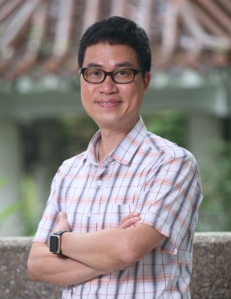

Professor Henry Shu-hung Chung received the B.Eng. and Ph.D. degrees in electrical engineering from the Hong Kong Polytechnic University, Kowloon, Hong Kong, in 1991 and 1994, respectively. He is currently Associate Dean (Research) of the College of Engineering, Chair Professor of the Department of Electrical Engineering, and Director of the Centre for Smart Energy Conversion and Utilization Research, City University of Hong Kong. He is a Fellow of the Institute of Electrical and Electronics Engineers (IEEE). His current research interests include renewable energy conversion technologies, lighting technologies, smart grid technologies, and computational intelligence for power electronics systems. He has edited one book, authored eight research book chapters, and over 460 technical papers including 220 refereed journal papers in his research areas, and holds 60 patents. He is currently Associate Editor of the IEEE Transactions on Power Electronics and the IEEE Journal of Emerging and Selected Topics in Power Electronics. He was Editor-in-Chief of the Letters section of the IEEE Transactions on Power Electronics in 2014-2018. He was Chair of the Technical Committee of the High-Performance and Emerging Technologies, IEEE Power Electronics Society in 2010-2014. He has received numerous industrial awards for his invented energy saving technologies.

